The **ATtiny85** is a small, low-power microcontroller from Atmel (now part of Microchip Technology), part of the ATtiny family. It is widely used for small embedded systems and electronics projects due to its compact size and simplicity. Here’s how it works and what makes it special:

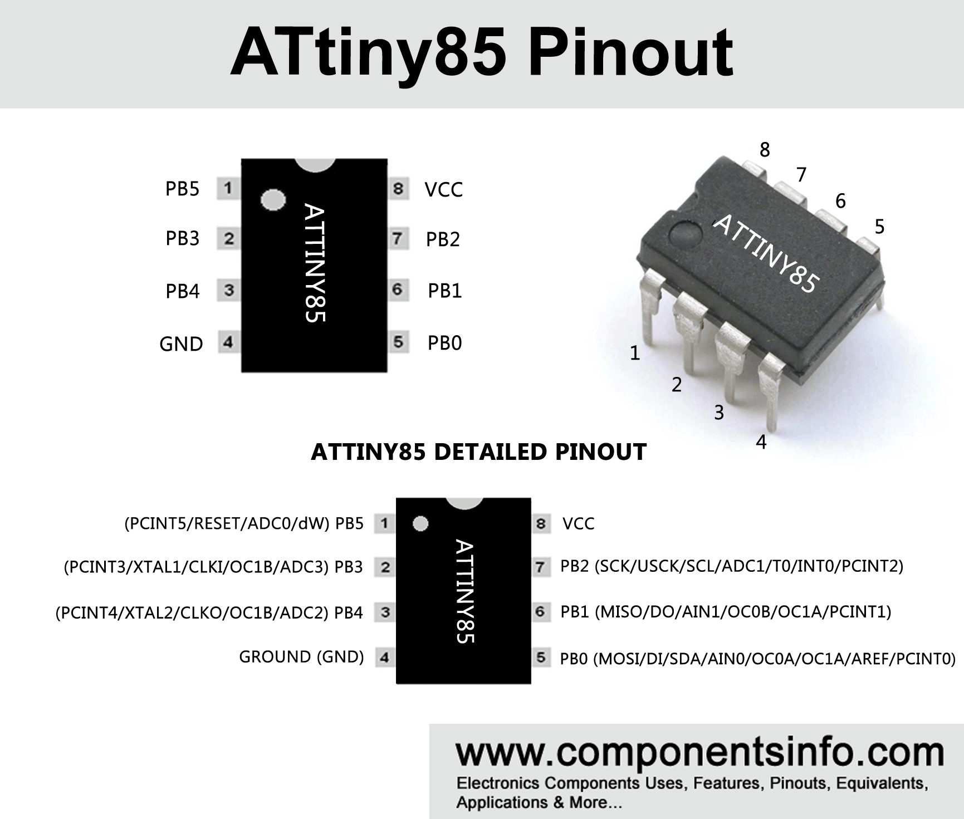

**Key Features:**

1. **Architecture**: The ATtiny85 is based on the **AVR architecture**. It has 8-bit processing power, meaning it can handle 8 bits of data at once.
2. **Memory**:
   * **Flash memory**: 8 KB (where your program is stored).
   * **SRAM**: 512 bytes (for storing variables during program execution).
   * **EEPROM**: 512 bytes (for non-volatile data storage).
3. **Clock Speed**: The ATtiny85 typically runs at **8 MHz** by default but can be overclocked to 20 MHz with an external crystal.
4. **I/O Pins**: It has **6 general-purpose I/O pins** that can be configured as inputs or outputs, with some pins also supporting special functions like PWM, SPI, or I2C.
5. **Low Power**: Designed for low-power applications, it can run on very little energy, which is ideal for battery-operated projects.
6. **Timers**: The ATtiny85 has a couple of timers that can be used for generating PWM signals, creating delays, or measuring intervals.
7. **Communication**: It supports **I2C**, **SPI**, and **serial (UART)** communications, which allow it to interact with other microcontrollers and peripherals.

**How It Works:**

1. **Programming**: You typically program the ATtiny85 using **AVR-GCC**, which is a set of tools for compiling code for AVR microcontrollers. The ATtiny85 uses a bootloader (or sometimes directly programmed via ISP — In-System Programming).
2. **Power**: It operates on a voltage range of 2.7V to 5.5V, making it suitable for a variety of projects. It can be powered by a battery, and it's often used in low-power sensor systems or portable devices.
3. **I/O Operations**: Its I/O pins can be used for a variety of tasks:
   * **Digital input/output**: Pins can read digital signals (high or low) or output signals (high or low).
   * **Analog-to-digital conversion (ADC)**: The ATtiny85 has a built-in ADC that can convert analog signals (like voltage) into digital values, allowing it to work with sensors that produce analog signals.
   * **PWM**: Some of the pins can generate Pulse Width Modulation (PWM) signals, which are useful for controlling motor speeds, dimming LEDs, etc.

**Applications:**

* **DIY Electronics Projects**: Due to its small form factor, the ATtiny85 is used in a variety of hobbyist projects, like creating simple sensors or controllers.
* **Embedded Systems**: It’s often used in devices where space and power are limited.
* **Wearable Electronics**: Thanks to its low power consumption, it is a good choice for wearable devices.
* **Automated Systems**: Can be used for things like controlling lights, small robots, or automation in homes.

The ATtiny85 is popular because it’s small, affordable, and relatively easy to use, making it perfect for simple projects where a large microcontroller is overkill.

A **potentiometer** is a type of variable resistor used to adjust the resistance in an electrical circuit, which can control the flow of current. It is often used to adjust voltage levels, such as in volume knobs on audio equipment or light dimmers. The term "potentiometer" comes from its ability to create a potential difference (voltage) across its terminals, which can be adjusted.

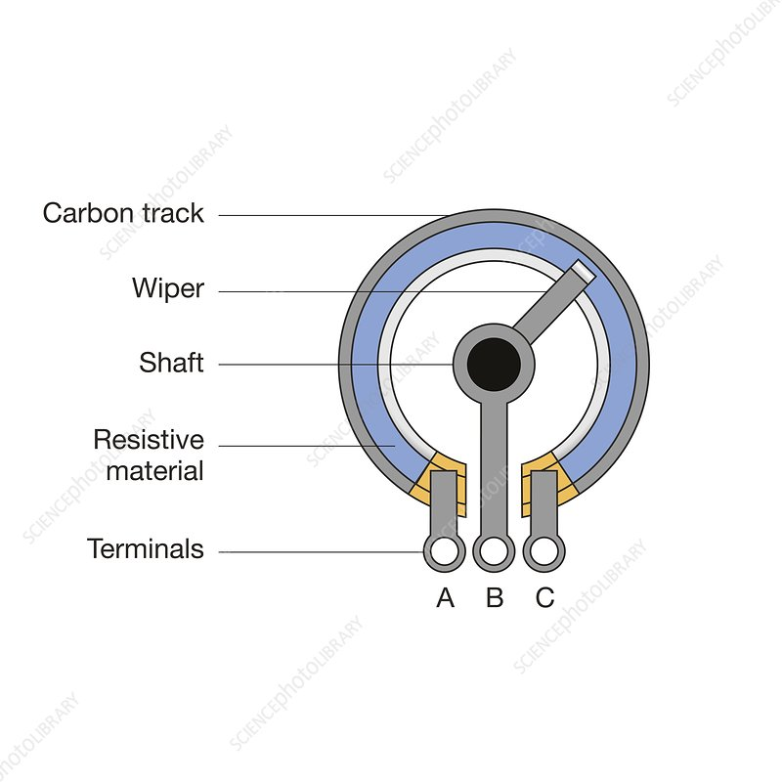

**Structure:**

A typical potentiometer consists of three main parts:

1. **Resistive Track**: This is a long strip of resistive material, usually carbon or metal oxide, that the wiper moves along.
2. **Wiper**: The wiper is a movable contact that slides across the resistive track. It connects to the adjustable knob or shaft and determines the resistance value based on its position on the track.
3. **Terminals**: There are three terminals:
   * **Terminal 1**: One end of the resistive track.
   * **Terminal 2**: The wiper (movable contact).
   * **Terminal 3**: The other end of the resistive track.

**How It Works:**

When you turn the knob or move the slider of the potentiometer, the **wiper** moves along the resistive track, changing the **resistance** between the wiper and the two outer terminals. By adjusting the position of the wiper, you can vary the resistance, which in turn controls the voltage drop across the potentiometer.

* **As the wiper moves** from one end to the other, the resistance between the wiper and each outer terminal changes.
* The **output voltage** is taken from the wiper terminal relative to one of the outer terminals.
  + When the wiper is at one extreme, the resistance is minimal between that terminal and the wiper, and the voltage at the wiper is close to the voltage at that terminal.
  + When the wiper is at the opposite extreme, the resistance is high, and the voltage at the wiper is close to the voltage of the other terminal.

**Applications:**

1. **Volume Control**: In audio equipment, a potentiometer adjusts the volume by controlling the output signal’s amplitude.
2. **Brightness Control**: In dimmer switches for lights, the potentiometer adjusts the voltage going to the light bulb, changing its brightness.
3. **Adjustable Sensitivity**: In sensors or other circuits, potentiometers are used to adjust the sensitivity of the device by varying the reference voltage.
4. **Calibration and Tuning**: Potentiometers are often used in circuits for fine-tuning or calibration of various components, like in amplifiers or voltage dividers.

**Types of Potentiometers:**

1. **Rotary Potentiometers**: These have a rotating knob or dial to adjust the wiper’s position.
2. **Linear Potentiometers**: These have a slider that moves linearly along the resistive track to adjust the wiper position.
3. **Digital Potentiometers**: These are controlled electronically rather than manually, often used in microcontroller-based systems.

**Key Points:**

* Potentiometers can vary from small, manual adjustments to large, precision instruments.
* They are commonly used in **analog circuits** and can also be part of a **digital-to-analog converter (DAC)** when controlled by a microcontroller.

In short, potentiometers are a simple and versatile component that allows for continuous adjustment of resistance in a circuit, with practical uses in a wide range of applications.

**Explaination :**

When you connect a potentiometer to an ATtiny85 to control an LED, the ATtiny85 reads the varying voltage from the potentiometer using its analog-to-digital converter (ADC). The wiper of the potentiometer adjusts the voltage, and the ATtiny85 converts this analog value to a digital value between 0 and 1023.

Once the ATtiny85 has the digital value, it uses this to control the brightness of the LED by generating a Pulse Width Modulation (PWM) signal. The duty cycle of this PWM signal depends on the potentiometer’s position: if the potentiometer is turned fully to one side, the ADC value will be high, making the LED very bright. If the potentiometer is turned the other way, the ADC value will be low, and the LED will be dim. The PWM signal essentially controls how long the LED stays on versus off during each cycle, so as you adjust the potentiometer, the LED’s brightness will change accordingly.

In short, the potentiometer varies the resistance, which the ATtiny85 reads, and in response, the ATtiny85 adjusts the PWM signal to control the LED's brightness.